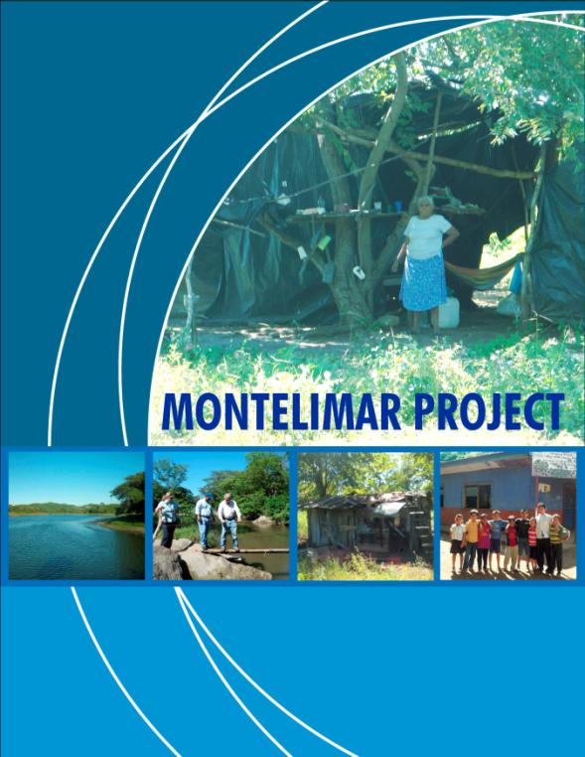

Socio-Economic Scoping Report

for

The Montelimar Project

Nicaragua, January 2013

Dr. Alfonso Chirinos Almanza

Consultant

January, 2013

Nicaragua

Table of Contents

Acronyms

Introduction 7

CHAPTER 1

OVERALL FRAMEWORK 10
  - Land holding in Nicaragua 10

  - History of Landholding Relating to the Ingenio Montelimar

and its privatization process 10

  - History of Government's Commitment to Former Military 11

  - Description of Montelimar Location and Possible

Risks or Advantages for Being Close to Tourist Potential Destinatio 11

CHAPTER 2

FAMILIES DISPLACED BY AMSA (220 HOMES) 12

Organization 13

Infrastructure 13

Basic Services 13

Education 14

Organization Support 14

Economy 15

CHAPTER 3

HOMES TITLED BY NAVINIC -181 HOMES 16

3.1 Loma Alegre Community 17

Economy 18

Basic Services 20

Health 21

Housing 21

Infrastructure 23

Education 23

3.2 Los Vivas Community 22

Nutrition 23

Infrastructure 23

Communication 24

Basic Services 24

Health 24

Education 24

Housing 24

CHAPTER 4
HOUSEHOLDS SCHEDULED TO RECEIVE TITLE DEEDS
108 HOUSEHOLDS 26

4.1 Finca Montelimar: Los Ríos Community 27

4.2 Finca Montelimar: El Campamento Community 30

Basic Services 30

Education 31

Transport 31

Economy 31

Risks 31

4.3 Finca El Apante: El Apante Community 32

Housing 32

Health 32

Access to Services 33

Risks 34

Economy 34

CHAPTER 5 34

WILLING BUYER / WILLING SELLER AND EXISTING LARGE ESTATE

CONCLUSION 38
Annex 1 Requirements, Costs and Schedule for Registration Procedures
For Households with Titles Deeds 40

Acronyms

AMSA : Agro Industrial Montelimar Sociedad Anónima
(Agro - business Company)
BANEXPO : Banco de la Exportación (Bank)
CEDRU : Center for Rural and Urban Development
ENACAL : National Company of Aqueducts and Sewers
FISE : Emergency Social Investment Fund
GoN : Government of Nicaragua
INETER : Nicaraguan Institute for Territorial Studies
IFC´s : International Finance Corporation
IBI : Real Estate Tax
MINED : Ministry of Education, Culture & Sports
MINSA : Ministry of Health
NAVINIC : Nicaraguan Shipping Consortium
PS5 : Performance Standard 5
WB : World Bank

INTRODUCTION

Nicaragua is an interesting country because of its economic, political, and social potential in Central America. This country has lands, climate, and human resources for farming, tourism, livestock, and mining, facing challenges that may bring new opportunities and open new horizons. Today´s generations are taking up such challenges and future generation will follow suit.

The subject of this report is a potential IFC investment in a company called NAVINIC, operating a sugar cane mill named “Ingenio Montelimar”, and numerous plantation´s of sugar cane in the Departmens of Managua, Leon and Carazo. Ingenio Montelimar (Montelimar) is owned by the Nicaraguan Shipping Consortium (NAVINIC), and is the smallest of four sugar mills in Nicaragua. It presently has a sugar cane processing capacity of 2,300 tons/day. The project will enable the Company to double sugar cane production and processing through: (i) acquisitions of approximately 1628 Ha of additional land for cane cultivation; (ii) improving agricultural infrastructure and drip irrigation; and (iii) purchase and deployment of green cane harvesters and transport equipment. In addition, milling capacity will be increased to 4,100 tons/day; with annual production increasing from 33,000 tons to 67,000 tons. The increased scale of operations will facilitate installation of a high pressure boiler and supplemental cogeneration plant in 2-3 years with concomitant increases in the sale of biomass-generated electric energy to the national grid.

In 2000, NAVINIC acquired land and assets that included a number of large farms, such as Montelimar, Loma Alegre, Los Jicaros, El Zapote and El Apante that all together totaled an estimated 8,400 hectares. At present, the Company operations include a total of forty-six (46) farms directly managed by NAVINIC. Currently thirty-two (32) farms are owned directly and planted with sugar cane by the Company and have no households located on them. In addition, there are eight (8) leased farms without any households located on them. A total of four (4) farms are owned directly by the Company and have households located on them in several defined communities, which are outlined in further detail below. An additional two (2) farms are in the form of colonato, which have no households located on them. Also included as part of the Company’s lands are areas which are not in sugar cane production, such as water bodies used for irrigation, protected areas and infrastructure, such as roads.

Adjacent to the company’s operations are lands now in the hands of the Government of Nicaragua (GoN). The Company discovered during the land transaction process when they acquired the land around the Montelimar Mill, that although some of the parcels were in original owners name, they rightly belonged to the Government of Nicaragua. As a result, the company decided to hand a portion of these lands (aproximately 2,900 ha) back to the GoN, signing an Agreement on July 2012. Prior to signing the Agreement, the GoN cadastral office (INETER) conducted a land survey to define the limits of the land.

The purpose of the report is to do some further analysis on the company’s land holdings and lands adjacent to the company’s operations in order to better understand the level of risks and land tenure issues present for the project. Displaced people (and their settlements) in the rural areas of Nicaragua after years of armed conflicts, have added a level of complexity to the development of private sector projects in Nicaragua. This report presents the initial findings of a scoping study into some of the land issues and risks facing the Montelimar project. Further work will be completed on the environmental and social impacts and potential mitigation of any identified impacts over the coming year, as part of the company’s commitment to comply with the requirements of IFC’s Performance Standards on Environmental and Social Sustainability.

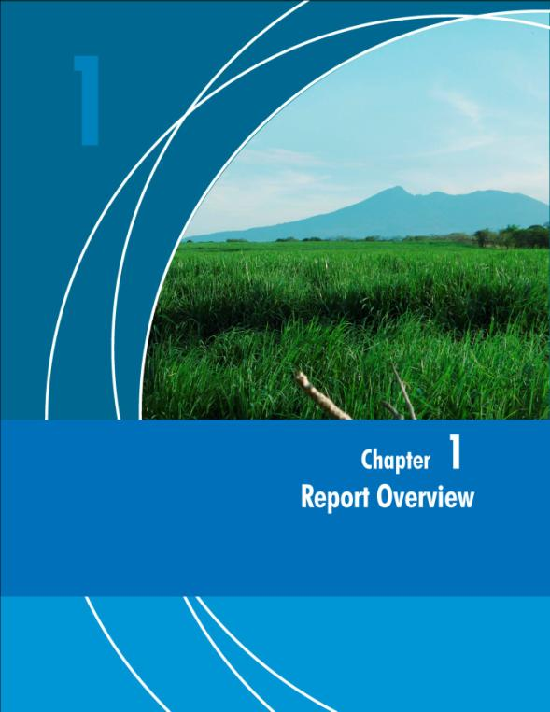

Chapter 1 OVERALL FRAMEWORK

  - Background on Land Holding and Legislation in Nicaragua in Relation to the Project

Ownership of property has been one of the most discussed and important issues for the country’s development over the last 33 years in its history. Also, there have been many conflicts because of political and economic interests at stake. In addition, the administrative and legal proceedings in such matters are not very clear and transparent. This makes the property ownership issue more difficult to understand.

Legally owned real property or land has been determined by political and social changes over the last 33 years. Up to July 1979, the Government had kept a private property system, showing a marked trend toward large landholdings. As of July 1979, as a result of a change of government, profound changes in all aspects of national life were initiated regarding property ownership, and as a result of different decrees and laws enacted, the system changed dramatically.

By October 15, 1992, the decision to privatize State-owned companies, was made, and 75% of the Ingenio Julio Buitrago would be e privatized within a 4-year term.

  - History of Landholding Relating to the Ingenio Montelimar and its Privatization Process.

The Ingenio Montelimar is located in the Municipality of San Rafael del Sur, in the province of Managua. The capital city, Managua, is also in the same province.

Most lands in such area are suitable for sugar cane plantations, but the area also has high tourist potential, having excellent beaches close to the capital city. This area is located about 60 km away from Managua city, and it is connected by two roads. These characteristics of the place make Ingenio Montelimar a very beautiful and desired property such place is highly valuable because of fertile lands and the large tourist potential along the Pacific west coast of Nicaragua.

From July 1979 until 1993 the State of Nicaragua is the owner of Ingenio Montelimar. The state then privatizes the Montelimar Sugar mill.,

The first company that acquires the mill in this privatization process is called AMSA (Agro Industrial S.A. Montelimar) in 1993.In 2000 AMSA assigns the assets to BANEXPO in payment of an outstanding loan, and it then sells it to NAVINIC.

  - History of Government's Commitment to Former Military

At the end of the 1980s, the Nicaraguan Army is one of the largest in Central America. Also, the country was at war: the Nicaraguan government was fighting 25,000 combatants who were members of the Counter revolution known as the “Contras”.

In this context, the five Central American presidents started a "process to build a stable and lasting peace in Central America" and signed the Esquípulas Accord. Its purpose was to stop the war and begin a democratization process in Central America. The Agreement, among other points, included a reasonable balance of military forces among the countries in the region.

Because of this, the reduction of the Nicaraguan Army started and thousands of people, who were part of the Army(peasants and workers), called for the government to provide social benefits, war victims pensions, requirements for property, life-long pensions, and scholarships, among others. These promises were made by the State when these various groups were leaving the army and opposition forces in the late 1980s and early 1990s.

  - Description of Montelimar Location and Possible Risks or Advantages for Being Close to Tourist Potential Destination.

The Montelimar beaches are about 6 km long and are one of the most visited tourist sites in Nicaragua. This area is located 60 km from Managua city. NAVINIC´s properties include stretches of land close to the beach, being just a few dozen meters from the sea. In this area, the Spanish hotel company Barceló also has a resort, which is a great attraction to tourists.

There are talks of some development Projects between the Nicaraguan Government and the Barceló Group, such as the project to rebuild an existing, abandoned landing strip for the use of international flights and a project to build a road along the coast. This coastal road would connect Masachapa (a town in the vicinity of NAVINIC) to the Costa Rican border. If this road is built, some of NAVINIC’s lands would be affected.

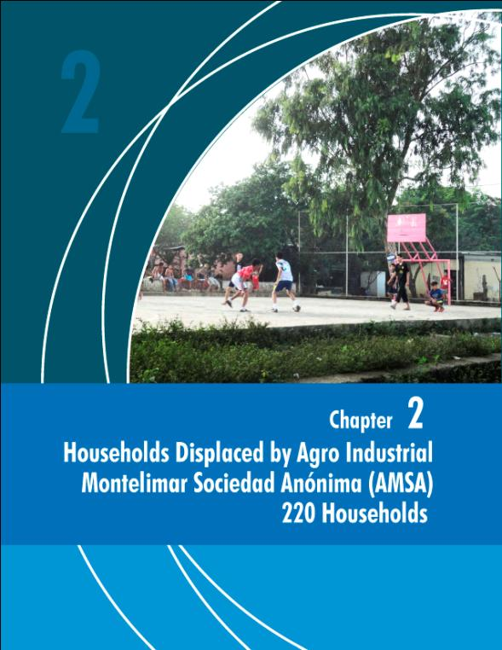

Chapter 2 FAMILIES DISPLACED BY AMSA (220 HOMES)

Once Agro Industrial Montelimar S.A (AMSA) takes over the plantation´s management, it starts to put in practice new policies, which included eviction of the population that lived in the surrounding areas of the mill.

There is no documentation of the displaced persons, only information obtained from NAVINIC that said there were 220 families affected. It is known that the displacement was done in several directions some of them in Los Cedros, Community La Gallina, San Rafael, Masachapa. Most of these 220 families that were affected, moved to the community of San Jose.

The San Jose community, which already existed at the time the displaced people arrived in 1992, was a community that had been established in a 38 ha area, which had been confiscated and given to an agricultural cooperative society during the 1980’s, as part of the Agricultural Reform process of the government. At the present time, this community is composed of approximately 1,700 inhabitants, reaching up to 3,000 when people from the surrounding rural areas are also included.

Organization

The community’s political organization is composed of 4 political secretaries per block and 1 Community Political Secretary. The block secretaries are responsible for taking notice of the population demands and taking them to the community general secretary. The latter is responsible for taking such demands to the mayor’s office and other institutions. The community is divided in 2 sectors, north and south, in which there are 28 house blocks.

Infrastructure

The community is located in a very good location, since it’s at the border of the Masachapa – San Rafael highway, which divides the town in two. This has permitted the San Rafael Mayor’s office to extend its highway embellishment programs, with nice street lighting and benches along the roadway. Also, it has extended its streets paving program and town enhancement.

Basic Services

Soon after the relocation the community had some water supply problems. It was not until ENACAL (National Company of Aqueducts and Sewers) solved the problem of water supply, when it created another project for a close by community called Los Vivas, which benefited the San José community.

Electricity was installed in the community for the operation of the first well. They had some problems due to high demand and a large number of people that accessed the service illegally. It was the community together with the electric company Union Fenosa that made legal electrification possible in the area 6 years ago.

Education

San Jose has a well equipped school. It offers complete elementary and high school classes. It has a student body of 560 students, 280 of which are female. The teaching staff is composed of 31 teachers, who also teach in several rural villages.

The school construction was made possible by the Social Investment Fund for Emergency (FISE) and is built of a block and cement structure, very secure and resistant. The secretary of the Center indicates that a classroom equipped with several computers was recently built, but they still need a teacher to head the children’s education for that special classroom.

Besides the school, there is also a well built basketball court, where all the children in the area can have physical education activities, since the access is open to the public.

Organization Support

There are several organizations that have worked to support this community; for example, CEDRU (Center for Rural and Urban Development), which is a center which helps people with develop projects to harvest basic grains, vegetables and fruits.

Similarly, the Nicaragua Plan has helped the community in building, educating the young, feeding the children and maintaining an organizational structure with which they work.

In 2012, Habitat for Humanity’s Nicaraguan Chapter, together with other organizations, among them NAVINIC, built 9 houses in San Jose.

Economy

The San Jose population has the alternative of working in several places. For example, there are people that work in the restaurants and beach pubs, others at Barceló, others go to the cement plant, and some engage in fishing and agricultural activities. Very few work in sugar harvesting for the Plantation

Since the families in this category of the study were displaced more than twelve years ago, participative observation was used as field work. There was no new survey work done in order to avoid raising expectations in the community.

The descriptions obtained from the interviewed people who lived and narrated the events; support the affirmation that the action executed by AMSA was an involuntary eviction. The surveyed inhabitants do not describe a negotiation process or location alternatives.

Except for San Rafael del Sur, San Jose is at the present time, one of the communities with more services and better living conditions. They have an excellent location being right beside the highway. Of all the communities in the study, their school center, is the only one that offers complete elementary and high school studies, and is seeking to obtain a licence to teach a technical level. Their political and social organization is very strong. They describe their achievements based on this organizational effort. These characteristics permit us to infer that it is unlikely that the people that arrived at San Jose due to the eviction are impacted by the potential project, as it happened a long time ago and people appear to be stable and prospering.

There is no census of the town and the information gathered points out to the likelihood that there are no existing claims from the historical actions of the AMSA company.

The inhabitants of the San Jose Community demonstrate good organizational and managerial capacity; as can be seen by their dynamic community. With the exception of the Habitat for Humanity project that involed NAVINIC, the community does not have much interaction with the company.

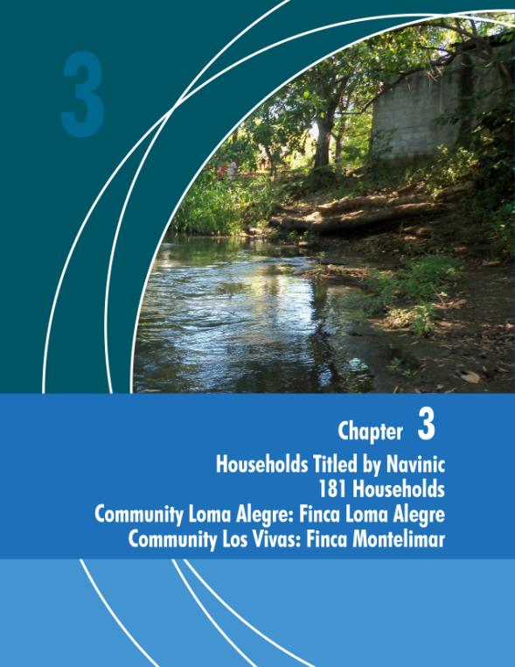

Chapter 3 HOUSEHOLDS TITLED BY NAVINIC (181 Households)

Los Vivas and Loma Alegre

NAVINIC has granted titles to 181 households living within their property on the Finca Loma Alegre and Finca Montelimar. On the Finca Loma Alegre, where the Loma Alegre community is located,there are 110 families. A total of 25 surveys were completed, this accounts for 22% of the population. On the Finca Montelimar, the Los Vivas Community is composed of 71 families and 20 surveys were completed to account for 28% of the population.

The titles of the beneficiary households in the community Los Vivas, are legally in order and ready to be officially registered. However, the beneficiaries of the Community Loma Alegre might struggle with the process of registering their property, because some of the information that appears in the titles apparently does not correspond to NAVINIC’s land registration data. To register their titles they will have to rectify before a lawyer and notary to include the correct data for the property donated to the community. This information was obtained from the office of the Public Registry of Property.

There are certain common characteristics and consequences in the titling process for both communities:

In the property titles issued to both communities, the following two conditions are established:

- FOURTH CLAUSE (DONATION SUBJECT TO CONDITIONALITY AND TERM CONDITIONS), that the titles on the received properties “cannot be transferred for a period of five years starting on the document delivery date” If this condition is not met, the realized donation is revoked. The date established in this clause prescribed in July 2011.

- FIFTH CLAUSE: (ACCEPTANCE) The person subject of the donation “assumes any existing evictions and redhibitory vices that this property might have without making the donor responsible”

100% the sample of the beneficiaries with these property titles have not registered them in the Public Property Registrar, even though the fourth clause mentioned above, has already prescribed.

Regarding the FIFTH CLAUSE which states that the beneficiary has to assume the evictions, redhibitory vices that the properties might have and which are not responsibility of the donor, NAVINIC.

It was verified that the sample used in the study for both communities, agrees with the list of households that NAVINIC benefited with property titles. Due to the fact that those benefited from the donations have not registered their parcels in the registrars office, the land is still under NAVINIC’s name.

Due to lack of knowledge of the registration process and the low educational levels of the beneficiaries, the titling of donated the lands in their favor is a difficulty that all beneficiaries face. .

It is important to mention, that the formal process of title registration in Nicaragua, is bureaucratic and expensive (Annex 1, processes, costs, time of registration).

The households know that the land they are living on is still legally under NAVINIC’s name; if they decide to sell, they will get paid a lower price for the property, because they would only be selling only the “possession” of the land.

Another common factor, is the high poverty levels in both communities; settlers having expressed that receiving the titles, has not improved their living standards; on the contrary, the future registration of their titles, will represent a financial hardship for them, given the fact that their current impoverished state is caused by high levels of unemployment in the area and this does not allow them to have enough resources to pay for the registration costs.

They are aware that as long as the title is not registered in their favor, they mainly have an economic problem (as expressed in the previous parragraphs), but they also face legal uncertainties because the land they live in is still under NAVINIC’s name. tDuring the study, the communities expressed they do not feel threatened by the Company, and in fact feel that the Company is trying to support them through this process.

3.1 Loma Alegre Community

The finca Loma Alegre is settled by the Loma Alegre community. This community is located in the territory of the NAVINIC Plantation, located approximately 4 Km south of the Masachapa highway.

This community is composed of the following sectors: Las Breñas, Miramar, La Presa, Los Muñecos, La Bolsa y Platanares o El Potrero.

The study considered 22.7% of the population that were benefited with titles. 12% of those benefited with property titles, have died. The beneficiaries of these titles will have to follow a particular procedure for their title legalization. There were no households found in the sample that had sold their properties.
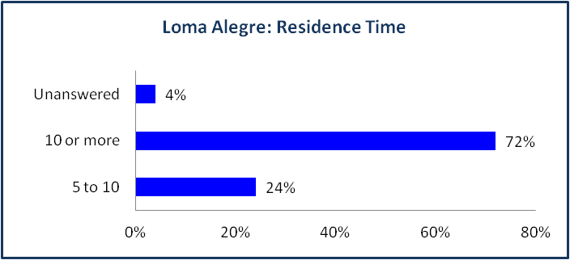
72% of the population has lived in this area for 10 or more years and the respondents have no major complaints of NAVINIC since all have their titles.

56.9% of the households are made up of 5 to 9 members, 4% more than 10 members and 40% less than 4 members.

Economy
A 42.5% of interviewed households have some members that work for the plantation in field tasks like sugar harvesting, foremen, etc. The community is approximately 4 kms away from Masachapa and this proximity allows them to find employment as security guards for nearby to farms, domestic work, and as staff in hotels and restaurants. The population is very rooted to their land and migration is low.

There are some local resources which the population uses to fulfill their basic needs. Water, for example, is obtained mainly from the river or irrigation ducts owned by the Company or they build their own wells to secure water supply. Fire-wood is obtained in the community surroundings. 68% of those interviewed express they have access to fishing, which complements their nutritional needs. 44% of the households rent their land to “colonos” that cultivate the land .

The population is affected by the fact that the employment in the mill is of a temporary nature, because employment is secure during the months of the harvest (approximately 9 months). The population perceives there is little labor stability and since not all of them have land for farming, their subsistence needs depend on the employees income.

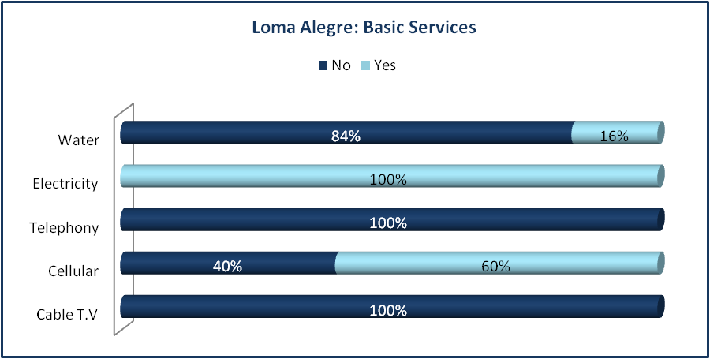
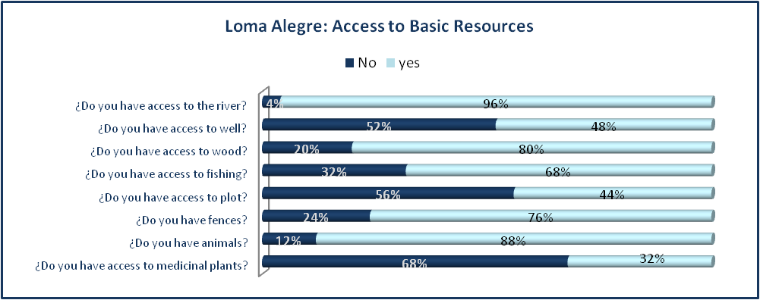
Those who farm land do so on rented land from private producers that still exist in the area. Since the agricultural activities of sugarcane are done during winter, the community’s economy tightens and this is critical for the people that have no other income. The months of sugar cane harvesting are the best for women, since they can sell food and attend the workers needs. The household economics improve substantially during this time.

Basic Services
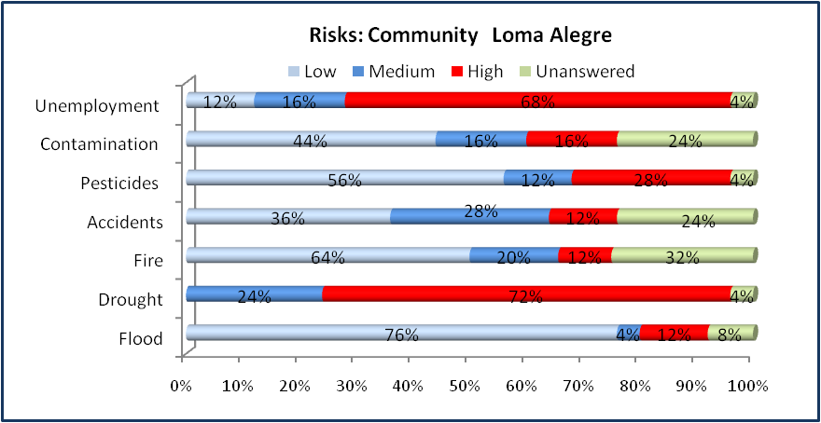
The Loma Alegre community lacks most of the basic public services, with exception of electricity. Electrification is the result of a project that a private producer developed to have electricity in his villa and resulting network passed by the community. The community made arrangements with the producer and he permitted they connect to the network.

Health

There is a health post in the community, which is attended by the Ministry of Health (MINSA). It does not have a permanent doctor; his attends patients on Tuesdays and Thursdays. A nurse attends the post all the days of the week. Workers explained that their creatinine levels are controlled twice a year, this worries them because if they come back with high creatinine levels, they are suspended from their tasks. The most common illnesses in the area are urinary tract infections, gastric problems, respiratory problems and intestinal parasites. Most of these problems are related to the quality of the water.

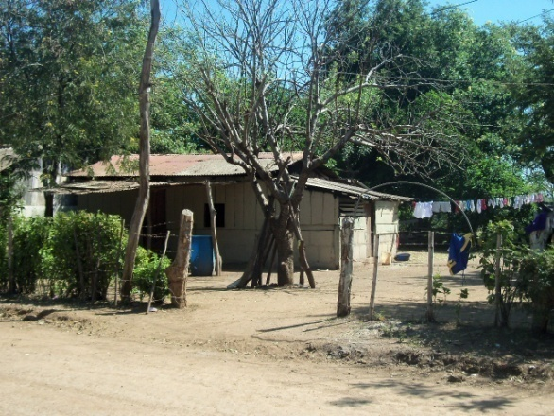
Housing

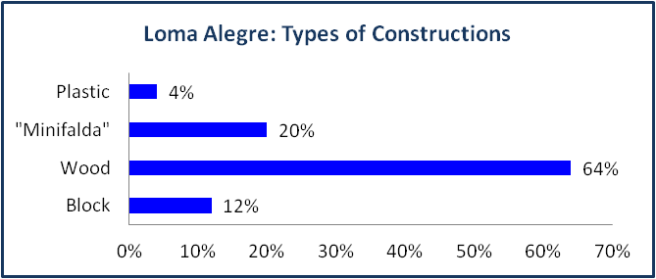
The population lives in plots of land where the community now is located. Houses are built with cement blocks and wood, have zinc roofs and most have dirt floors. In general, the plots have fences and the terrain is flat, little prone to flooding; however there are flooding risks for that part of the population that live near the river; these risks are high because they have areas in their property (for example fencing and subsistence harvests) that have been lost to the river each year.

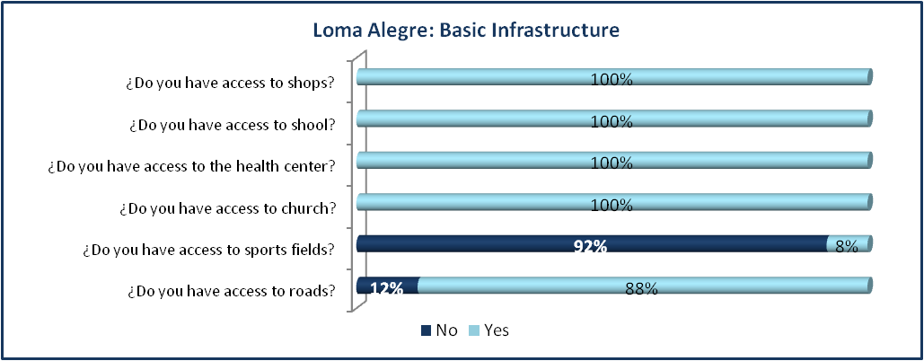
There is also fire risk when the sugarcane is burnt. Although this risk is mitigated by the fact that the Company uses the norms indicated by the Ministry of Forrestry to burn the residual plants in the fields. They have emergency equipment on hand in case of an uncontrolled fire. Respiratory illnesses seem to increase during this time of year.

Infrastructure

In general, the population states that they have access to the communities’ basic infrastructure. In the Loma Alegre community, 100% of those interviewed said they have their property title, but during the visit and identification of the site, we found that approximately sixty six new families have currently settled there, which have no property titles, claiming they are waiting for NAVINIC or the State to issue their titles.

Education

There is a school that offers pre-school and complete elementary (multigrade) education. The student body consists of 146 students in all the grades. There are 6 teachers, 4 in the morning shift and 2 in the afternoon. There is no electricity, the roof is falling, the latrines are in bad condition, and there is no water due to the neglected well.

3.2 Los Vivas Community

This community is located in the 61 km mark of the Managua - Masachapa highway, turning approximately 6 km due north. It is near the ocean and tourist facilities like beach hotels. It is settled within the Finca Montelimar.

A total of 71 families were issued Property Titles. A sample of 28% of the population was studied. Approximately 37 households appear to have moved into the area relatively recently.

5% of the owners of the titles, have died and their families live in their relative’s properties and 15% have sold the possession of their land, even though their property titles are not registered. One of the properties was sold for an estimated US$1,386. These people will have to fulfill certain procedures to obtain their property registration.

The population is settled on both sides of a small river known as Los Vivas. Three sectors are distinguished along the river: El Trasmayo, La Colonia y Masachapa.

The families in this sector are generally well established and formed by 5 to 9 members in 45% of the cases, more than 10 members in 15% of the cases and by less than 4 members in 40% of the cases.
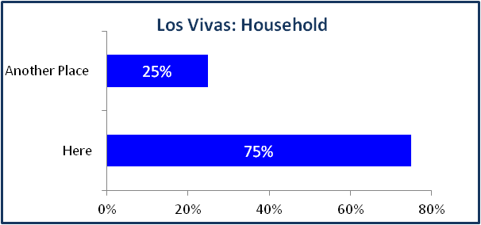
Due to its proximity to Masachapa and to communication and transportation means, 75% live in the community and only 25% live in other places.

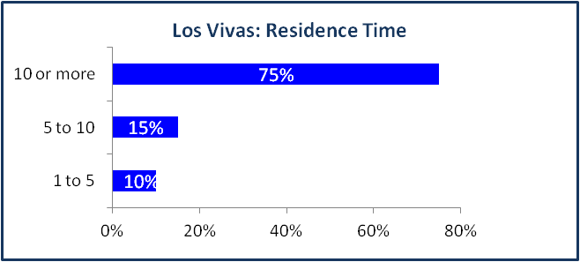

75 % of the population has lived in the area for more than 10 years, some have lived there for 28 years and others were born there.

The population has access to electricity because NAVINIC installed the electrical network up to a certain area of the community. They express they have not been able to have access house building programs and latrine construction programs because they do not have their titles registered properly.
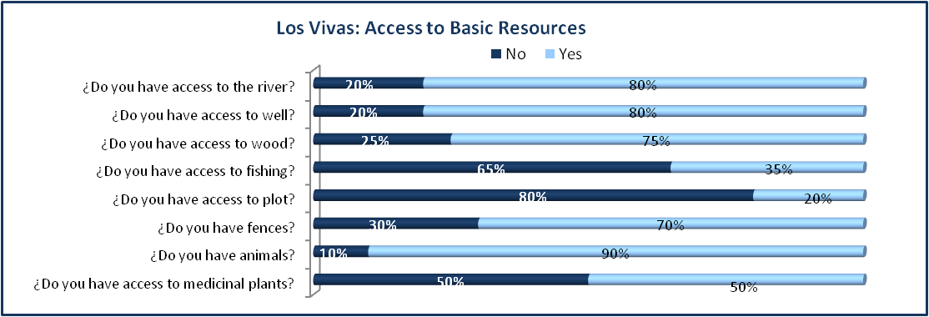
Nutrition

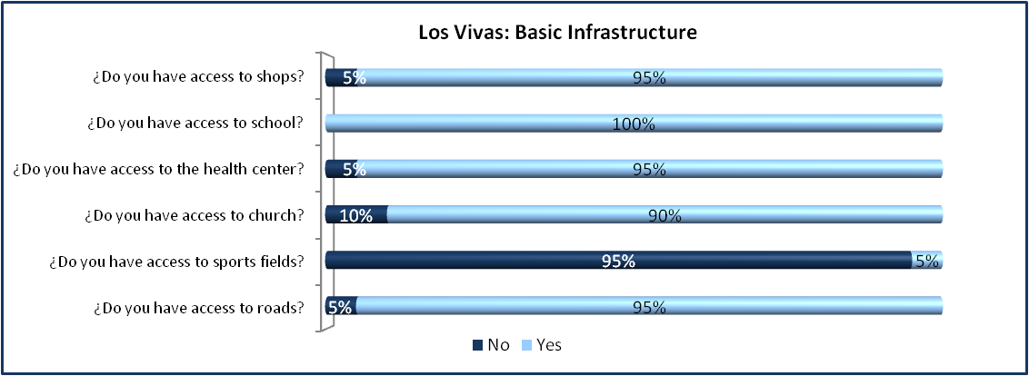
The general diet is based on rice and beans. The people who live near Masachapa have access to the ocean and they buy shell-fish at low cost. The vegetables they consume are mainly onions and chiltoma. Pork, chicken and cattle meat is rarely consumed. The tortilla is also rarely consumed; instead, the guineo and bananas are preferred.

Infrastructure

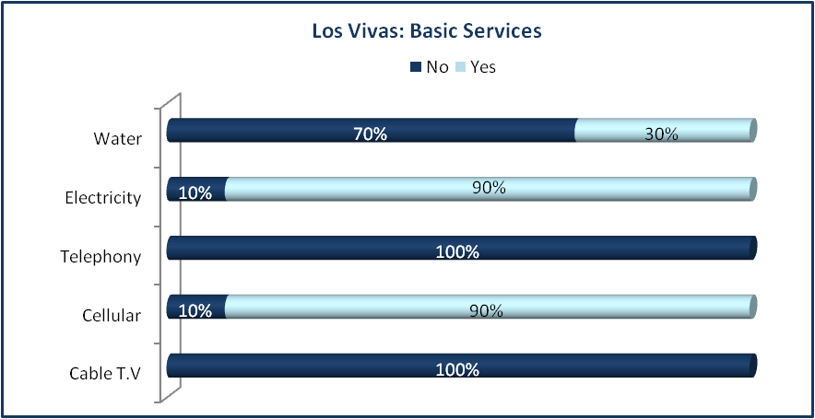
This community is close to the sugar-cane plantation and the woods corridor that forms along the Los Vivas River, and is near the highway that communicates Masachapa with San Rafael del Sur; therefore they have good access to transportation means. Internally, the access to homes is through trails made by the sides of the sugar-cane plantations and only accessed by bicycles.

The communitry travels to Masachapa for other public services such as education, health, recreation, and even churches and stores.

Communication

The population has access to Pochomil and Masachapa through a public bus that travels to Masachapa twice a day. Another means of transportation are the moto-taxis that constantly enter the community and solve the transportation problem.

Basic Services
The Los Vivas community does not have potable water services. The main water supply is river, which according to the community, is polluted. Some people have wells; however, most of the population is exposed to health problems. Most of the population (90%) has access to electricity; however, it is illegal. Cellular phone service covers the area with the two existing networks in the country.

Health

In this sector there is no health center. The population is attended at the hospital in Masachapa. NAVINIC does not offer any health services to the population that does not work in the plantation.

Education

The student population is attended in the Masachapa schools. The levels are complete elementary and high school.
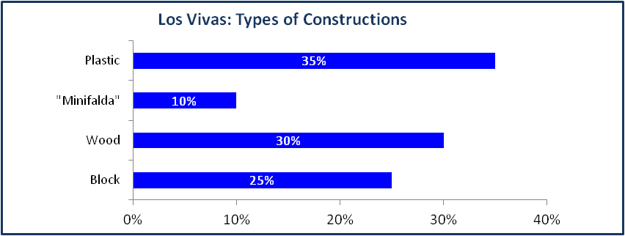

Housing

The construction of the homes located near the river is unsafe. There are many structures made of plastic, zinc and wood debris. In the El Trasmayo area the more permanent structures (29%) are located besides the highway.

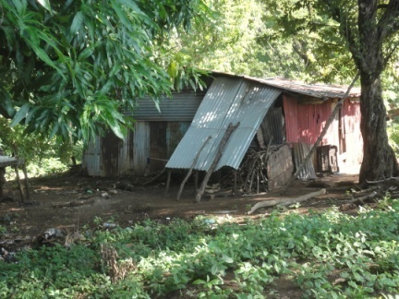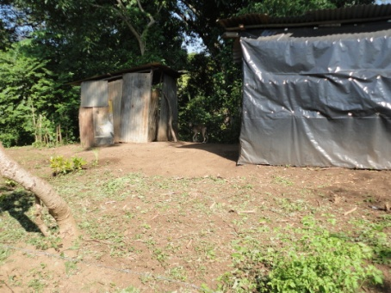

55% of the community works for the Company in permanent tasks or in sugar harvesting. Due to its proximity to Masachapa (beach resort, with hotels and restaurants) some of the members of the community work in the restaurants and hotels.

The people of the community use the river to wash their clothes and other utensils, as well as to dispose garbage that runs down the river. There is lack of latrines and river protection services. The people pointed out that the river is contaminated by human and animal feces.

Although the population does not perceive a high risk of flooding, technically it can be observed that they could be vulnerable to this phenomenon.

When the people with properties closest to the river and with a high risk of flooding, were asked about the possibility of relocating to other less vulnerable areas, they expressed their consent, as long as they were accessible, nearby and with better conditions than they actually have.

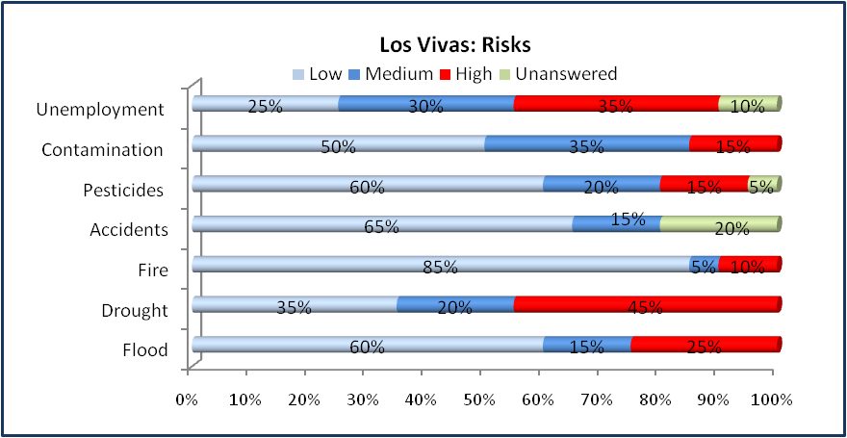
Of the sample that was applied in Los Vivas, 95% belongs to the list of people that NAVINIC had stated as beneficiaries, but a 5% was found that do not have a property title which could mean they are new settlers. This information is the same as the 5% reflected in the chart category of persons within the less than 5 years of residency in the area.

These people are at high risk, due to their location at the river bank, which increases its flow each winter, reducing the property areas, risking their lives, belongings and animals.
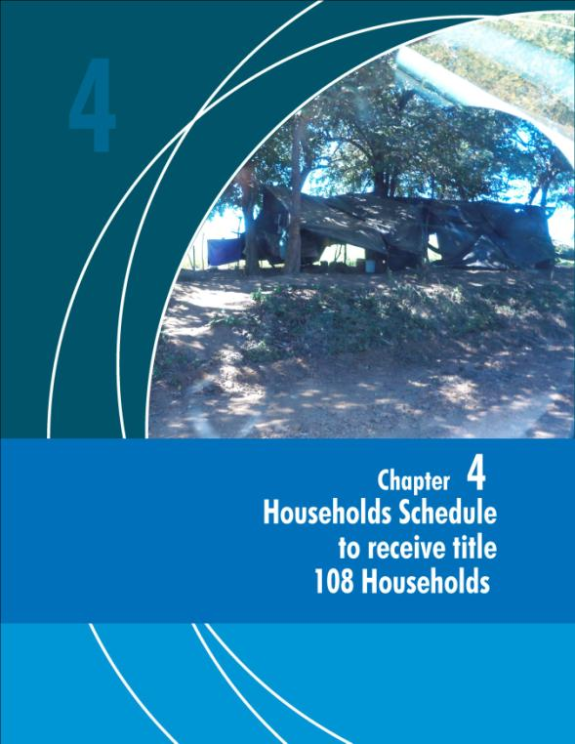

Chapter 4 Households Scheduled to Receive Title Deeds. (108 Households)

NAVINIC is scheduled to hand over land titles to 108 families in three communities. Located in “the fincas” Montelimar y el Apante.

Within the Finca Montelimar are settled the communities el Los Río and el Campamento. The communities are near the Sugar Cane Mill

Due to the different nature of the communities, , a decision was made present independent results for the findings of each community.

4.1 Finca Montelimar: Los Ríos Community
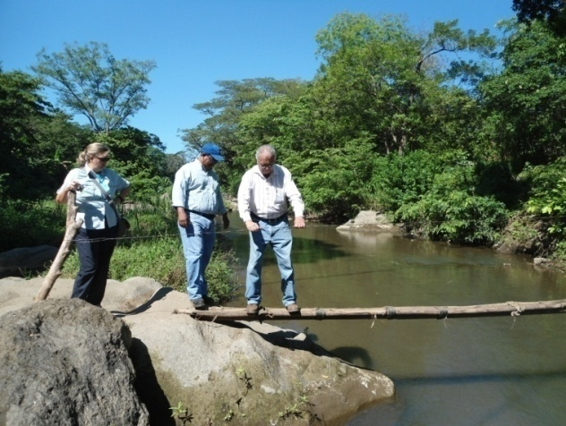
The Community of Los Ríos is made up of a population of 36 families with 87 people, 60 adults, representing 69% and 27 children is 31%. Eight surveys were done, which represents 22% of the population. This community is next to the sugar cane mill - about 800 meters away, but it is not in the farming area.

Regarding access, it is extremely difficult to get to this community: you can only enter by walking, and it is also necessary to cross a river that separates the community from the Mill. The way to cross this river is primitive: there are only logs lying for people to walk on them, holding a rope to avoid falling.
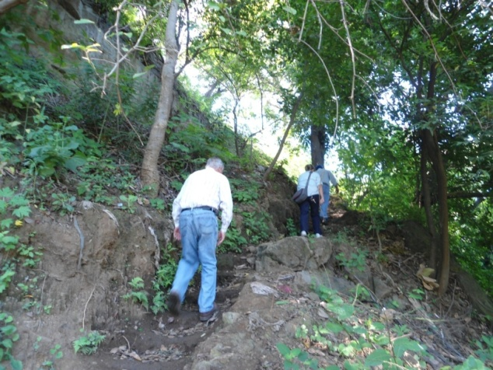
Difficult access to this community is a great obstacle: people do not have access to public transportation, keeping them from performing jobs. Lack of transport keeps youths from attending school, and they prefer to migrate.

This is an old community made up mainly of old sugar cane workers. Today, only the oldest retired workers still live there, the new generation has migrated because of lack of jobs. 100% of the population under study has been living more than 10 years in the community.

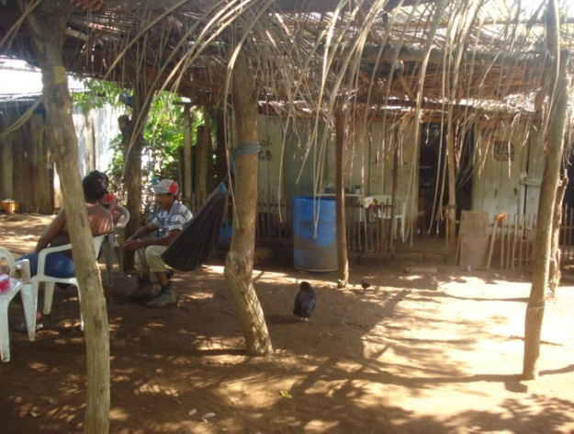
This community that is located in the grounds of the sugar mill, is characterized primarily by low levels of education, workers have no incentive to make improvements to houses or the environment where they live.

The construction of houses is extremely precarious, they use wood , plastics and metal (zinc).

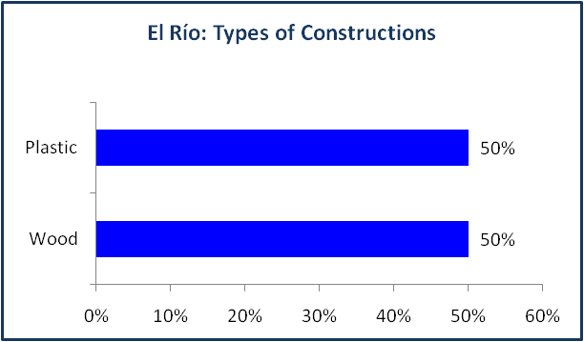
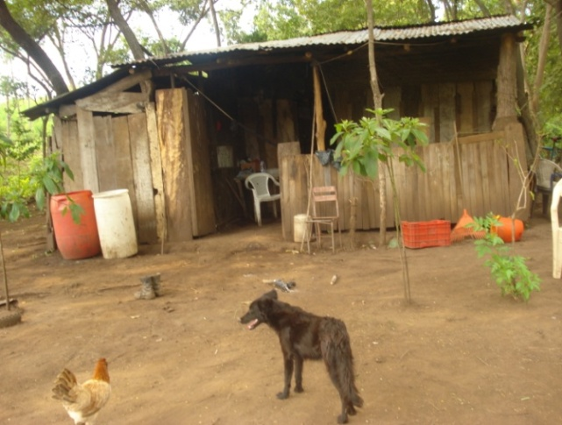
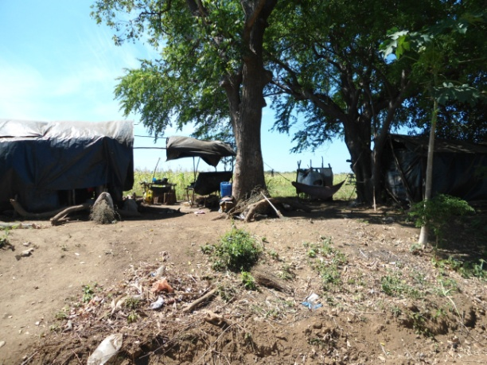

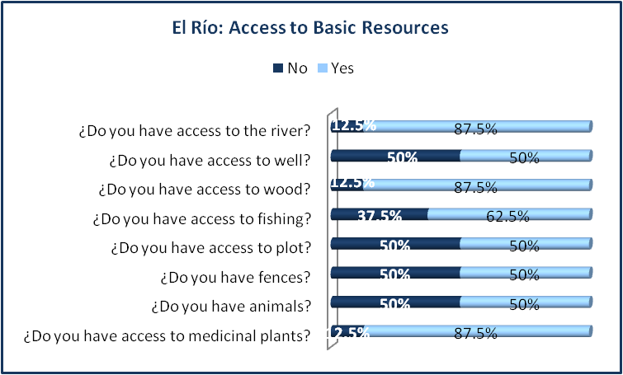
87.5% of the people have access to the river, but 50% of them have chosen to build wells for water. Firewood is used for cooking, and 87.5% of the people bring firewood from surrounding forests. On the other hand, 50% of the people have access to plots to grow their food crops.
Risks

The living conditions in this zone are difficult, the situation worsens when, according to the dwellers complaints, during the time of the sugar harvest they believe the Mill throws liquid waste into the river. This affects the fauna and population living on the banks of the river. According to the company this was the situation in the past. However, today the company no longer disgards liquid waste into the river, and reportedly complies with the national laws for the dispoal of liquid waste. People also complain that there is a high degree of pollution resulting from pesticides released into the air. The application of pesticides is according to the norms and regulations of the Ministry of Health, the Ministry of Agriculture and Forestry, Ministry of Natural Resources and Environment and the Ministry of Labor. There is no proof of the complaints or preceptions that the community has of the Mill operations and the company should conduct further community engagement to reassure communities of their concerns. Another source of pollution - according to inhabitants - is the smoke when burning the sugar plantations or fields.
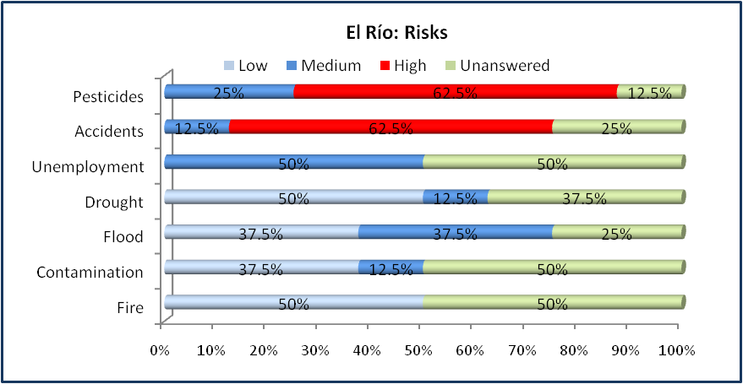

Fifty percent (50%) of the households is made up of 5 to 9 members; 87.5% of respondents work in sugar cane planting and harvesting at the Ingenio. At the same time, income to support a family is gained by engaging in other activities such as fishing, farming, and marketing of their products -hens, eggs, pigs, lemons- also some others are construction workers. 12.5% of the people work independently.

In this community, 100% of the respondents do not have title deeds. They do not know the laws or the procedures to register a title deed or land title.

4.2 Finca Montelimar: El Campamento Community

This community is located at kilometer 59 of the highway Managua - Masachapa. It is the closest community to the sugar mill.

In the Community el Campamento indicates that there are 18 families, with a population consisting of 83 people 49 adults representing 59% and 34 children by 41%. 4 households were surveyed, which represents twenty-two percent (22%) of the population.

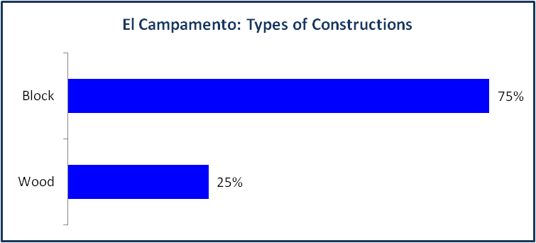
Houses in el Campamento community have been built by the Montelimar Mill for more than 40 years. These are old houses made of cement blocks and asbestos roofs. Today, they are run-down houses, but people use them. Some houses have roofs made of straw.

100% of the population has lived there more than 10 years; 50% of respondents say they were born at this place. This community has a cemetery. 75% of the households are made up of 5 up to 9 members.

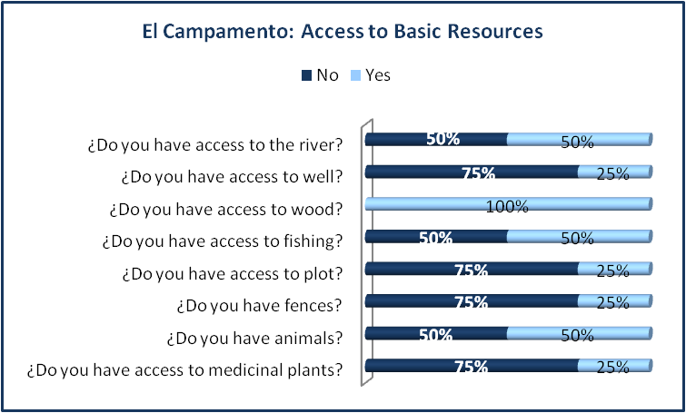
Basic Services

Electricity was brought by Union Fenosa electric company. They do not have electricity meters, but they pay electricity bills. There is no running water: they drink water from wells and creeks, including irrigation canals when they are working.

People´s access to plots for producing foods is quite limited (25%), this happens in every area where the company has production areas.

The normal diet is based on rice and beans. Vegetables are usually onion and sweet pepper. Proteins, such as meat, are consumed once a month. The energy to cook food is a product of the villagers collecting firewood from the surrounding area.

Education

The school goes up to the sixth grade, with independent classrooms. There are 4 teachers paid by the local office of the Ministry of Education, Culture, and Sports (MINED) in Villa El Carmen.

Transport

There is no public transportation; however, motorcycle taxi is a means of transport that helps people move around. Their main destinations are Villa El Carmen and the main road that connects to Managua, San Rafael, or Masachapa.

Economy

75% of the household heads work in the mill during the harvest and in the mill’s workshop, however, 100% of those surveyed said unemployment as their biggest concern because the other members of the household are unemployed when the harvest period ends. The surveyed population said they conducted as parallel activities, such as fishing, collecting clams and 25% perform temporary work outside the community.

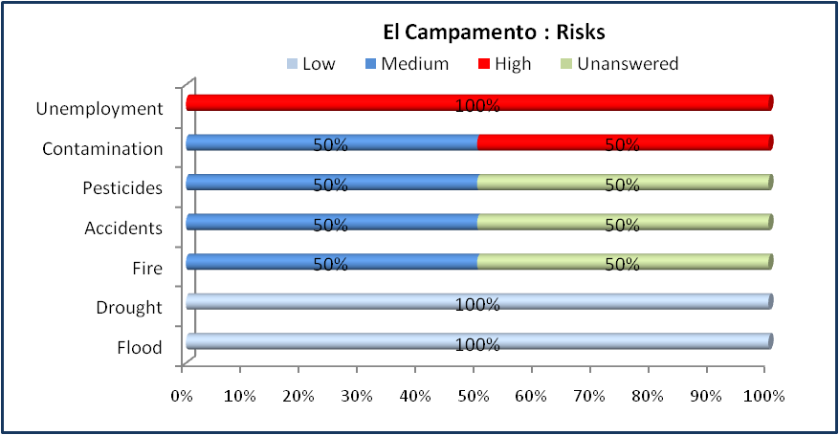
Risks

According to the survey, all villagers perceive that their community has pollution problems: 50% consider pollution levels to be high, and the other 50% considers pollution levels between medium and low.

The population describes pollution as a result of pesticides released into the air. Through infiltration, this pollution affects water —used by the population— when getting water from wells. They are also exposed to smoke from the burning of cane. The company tests the water courses in the area, according to the Ministry of Health and the National Water Authority standards and these agencies verify this information. The company follow the Ministry of Agriculture and Forestry law regarding water pollution. The company should engage with communities to address their concerns about pollution and health matters.

4.3 Finca El Apante

The Apante Finca is located at 44 km on the road to Montelimar, and it is about one km away from the road. In this community, where 54 families are scheduled to receive title, 12 households were studied, representing twenty-two percent (22%) of the population.

This locality has two big attractions and natural resources. It has thermal waters and natural spring; the latter is a water source for communities like Villa El Carmen and other.

This population has lived in this community more than 10 years; some people have lived up to 58 years. The plots vary between 0.175 and 0.70 Has.

In 21% of the sample, family members have migrated to other sites. Many of the children live with relatives in the camp and others in surrounding communities.

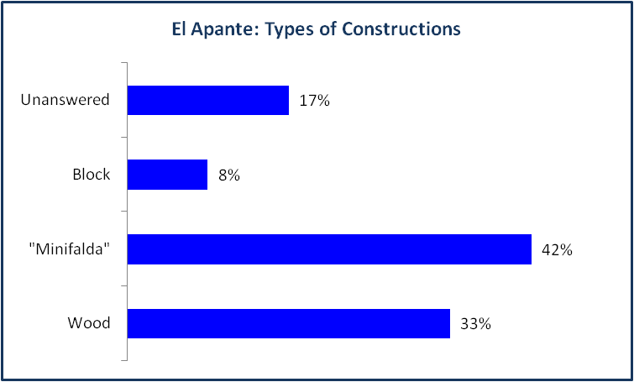

Housing
On the housing quality, 100% of the homes under study were made of blocks, stone, and wood; some homes even have concrete floors.

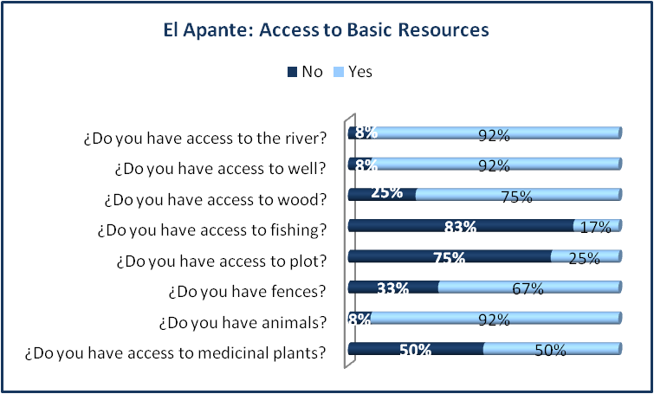

Health

There is a health post of the Health Ministry (MINSA) in the community. It provides the following services: Pre-natal control, family planning, and vaccination, having a physician twice a week. Common diseases are respiratory, intestinal type, and kidney infections. Whenever there are more severe health problems, people go to the Health center of Villa El Carmen. For those who work at the Ingenio, there is a program in which workers may have an assessment at the NAVINIC is Clinic, before a referral to the Managua Military Hospital.

Access to Services

This population benefits from electric power provided by the mill, and 92% has water well. People who work in the Company have access to school, commissary of the sugar mill, and the clinic.

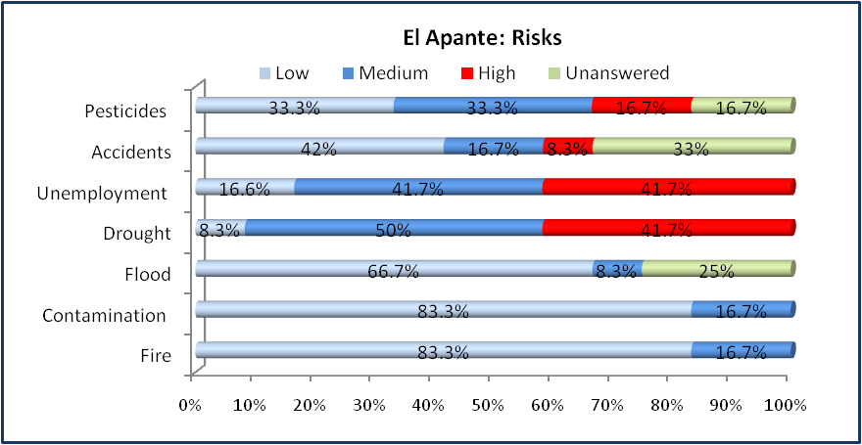

Risks

Some inhabitants talk about fears of polluted water resulting from pesticides released into the air. Another source of pollution -according to the inhabitants- is the smoke when they burn the sugar cane plantations or fields.

Economy

Fifty percent (50%) of the workers work at the Montelimar Ingenio. The other 50% of families depend on agriculture, planting basic grains. Also, they are engaged mainly in raising cattle to produce milk, and some people have jobs as government employees and security guards in Managua. 10% of people are widows and widowers (10%), receiving surviving spouse´s pensions. During the sugar cane harvest, women have an opportunity to prepare food or meals, which they sell to workers engaged in harvesting.

In these communities, 100% of respondents do not have title deeds. They say they have felt that NAVINIC has not discussed their relocation. Their presence for staying in these lands depends on management of NAVINIC, since respondents do not have title deeds. Nobody knows about the procedures to be followed for land titling - getting title deeds. The 100% not know what the process for the legalization of land titles (Annex 1.0).

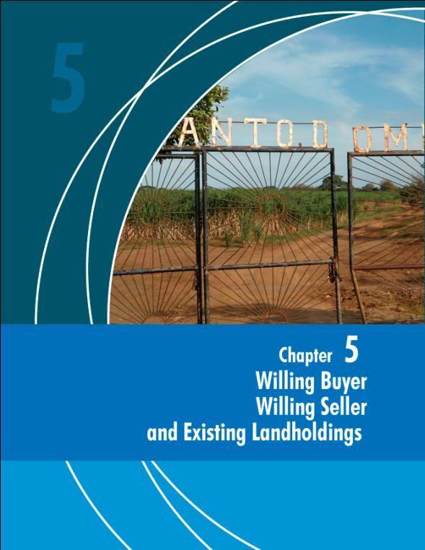

Chapter 5 WILLING BUYER / WILLING SELLER AND EXISTING LARGE ESTATE

The Company reported owning 46 farms which they use to grow sugar cane. This number coincides with the demarcation of these properties on the plans provided by NAVINIC. Of this total, of the 46 farms, NAVINIC has classified them into four categories. Owned farms without Population, Leased Farms without Population, owned farms with some settled population on them and Colonato without population.

# | Own without Population | Rented without Population | Own with Population | No Colonato Population
1 | San Pedrito * | Azahualpa 1 | Loma Alegre ** | La Virgen
2 | San Pedro * | Azahualpa 2 | Jícaros “B” | Las Cañas
3 | El Cacao * | El Modelo | Montelimar **
4 | Vasconia | La Concha | Apante **
5 | San Antonio de la Barra | El Papayo
6 | La Cholpa | El Madroñal
7 | Santa Cruz | Santo Domingo *
8 | San Ramón | El Rosario o Santa Rosa *
9 | Buen Suceso
10 | Waterloo
11 | San Joaquín
12 | Santa Isabel
13 | La Chinampa
14 | Chiripa Apante
15 | El Rosario
16 | La Ceiba
17 | El Rito
18 | La Francesa
19 | La Banqueta
20 | Corrales Negro
21 | El azote
22 | Anexo Jícaros “B”
23 | Gallina Platanera
24 | Rio Gallina
25 | La Gallina
26 | Nambiras
27 | Cuenca A y B
28 | El Rodal *
29 | Rodal Anexo *
30 | Santa Juana *
31 | El Porvenir *
32 | San Diego
*Farms visited in the study
**Farms visited
The company reported that of the 36 farms owned by NAVINIC, 32 are no settlements. Of these farms owned NAVINIC, the company claims that four of them have settled population within the property.

Evaluated farms are located in the following departments:

Masaya:
- El Rodal
- Anexo Rodal
- El Provenir
- Santa Juana
León:
- San Pedro
- San Pedrito
- El Cacao

Granada:
- Santo Domingo
- El Rosario

The main features common to all the farms visited, own and rented without population are:

- The areas of each property vary between 350 and 119 Has of land.
- All areas are planted with sugar cane, with no other developing crops.

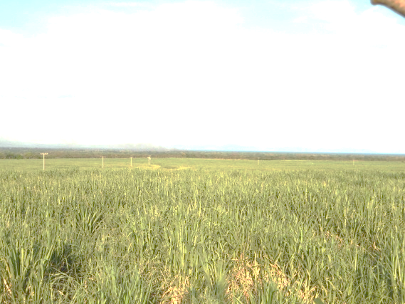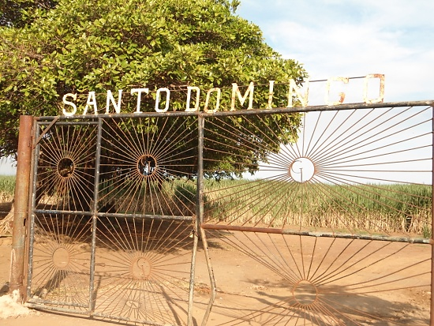

- The area of irrigation areas vary between 162, 4 and 119 Has of land.

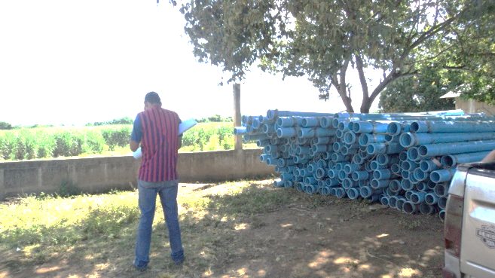
El Rodal, irrigation tube
- NAVINIC is interested in buying land, but has a policy of buying areas not less than 50 has.

- None of these nine properties visited have people settled on the farms, except the guardians or overseers. The people working in these areas live in the surrounding towns.

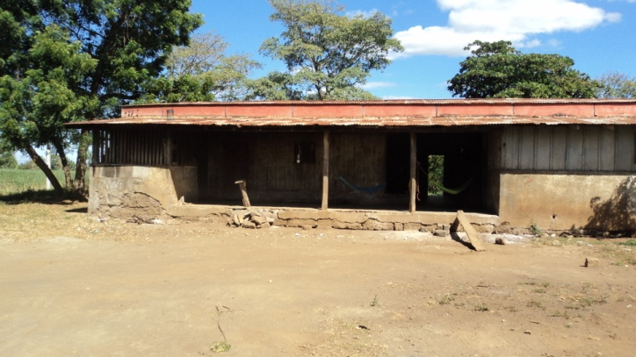
Foremen camp, El Rodal

- During the time of this study, there was an attempted land invasion, but since NAVINIC has guardianship system on these farms and their boundaries defined, the company called the police who arrived and asked the settlers to leave. It was non confrontational and people left once they realized they were on private property.

- As found no population living within farms owned or and leased to NAVINIC was decided there was no need for further surveys.

We believe that there is no risk of invasion of these farms, because monitoring controls are in place, and if there are any they are dealt with as the one described above.

NAVINIC says owning two farms in Colonato a form of relationship between the Ingenio and the owner of the land, in which the landowner cultivates a product but is provided with, inputs, paid at the time of harvest, besides the value of the earth and the product obtained.

Conclusions

NAVINIC, has been working on the provision of titles to workers and their families living on their lands and some who have been there illegally, in order to try and fight the poverty that is so obvious in el Río, el Campamento and los Vivas - on some farms of the company. Also, it is important for the company to start to develop some plans, with local communities to carry out some potential improvements in the area. Although it is less significant in terms of investment, it is essential and urgent to build for example, a bridge that would connect the communities of el Río and the Mill, for example.

The communities and households in questions, lack of knowledge of the formalities to obtain a final title deed is a number one constraint, including the costs to be paid for a title deed.

Likewise, since people located in NAVINIC have a good attitude towards the company, the company could think in terms of deploying some social services, basically, by having a social worker to look at the most pressing needs of the people living in its lands.

For the sake of securing such properties, the company should fence, as clearly as possible, its own lands, to prevent eventual claims of possession that could arise in the immediate future. These actions will help the solution of the land problem in this area. It is necessary to think of the Nicaraguan extended family which is gregarious with 29 new births per 1,000 inhabitants in 2012. Although the birth rate is diminishing, it is still one of the highest in Latin America.

The company will develop a management system to strengthen its proactive information to the communities related to frequency of spraying and sugar cane burning, and document general information and that the relevant parties (neighbours, elders, etc.) have been informed. The general time-frame will be publically available in the communities involved. The Montelimar community liaison team will further provide for general question and answer sessions in the communities involving the agro-business team informing the communities about the aerial spraying and quema de cana procedures of Montelimar, describing potential risks and measures to be taken by Montelimar and the communities targeted to mitigate these risks. The general time-schedule will be posted at publically available locations in the communities and any changes in schedule will be communicated to a focal point in the communities. Site- and time-specific information on chemicals applications will be made available to third parties upon request.

This project involves responsibilities and the well-being of hundreds of people, including the responsibility of national and international organizations to provide support.

Mitigation measures for some of these issues will be implemented by the company as part of their ESAP .

Annex 1.0

Requirements, Costs and Schedule for Registration Procedures for Households with Title Deeds
Once the cadastral certificate, fiscal receipt, cadastral survey, and municipal tax solvency are incorporated into the deed, this is submitted to the Property Registry for its proper registration and 1% fee of the cadastral value is paid. In these cases, the payment is to be about U$ 125.00 (one hundred twenty - five dollars). The Registry will open a new registration account for each beneficiary. This will be the end of the process for legal ownership over their property.

Cost of Procedures for Title Deeds

Procedures | Procedure Cost
- Certificate of Registered Ownership | U$ 10.42
- Digital Plan | U$ 41.67
- Approved INETER Plan | U$ 15.00
- Certification of Copies | U$ 8.33
- Catastral Certificate | U$ 12.50
- Average Cadastral Value | U$ 125.00
- Registration fee payment | U$ 125.00
- Pay for registration of tickets | U$ 20.83
Total in dollars | U$ 358.75

- This does not include Real Estate Tax (IBI) to be paid in the municipality office.
- The municipal tax solvency must be requested in the name of NAVINIC.
- NAVINIC must pay this tax (solvency)

Amount of Time to Complete Procedures

Procedures | Days
Approval of Plans | 12
Cadastral Certificate | 6
Certificate of Registered Ownership | 5
Proof document of Cadastral Appraisal | 12
Registration at the Property Registry | 30
Municipal Tax Solvency (if there is dismemberment of ownership) | 3 to 5
Municipal Tax Solvency (if there is no dismemberment of ownership, one has to wait for a field visit or inspection) | It may take several days, as scheduled

